**Yoobee College of Creative Innovation - Christchurch Campus**

**Diploma in Software Development 2202-Online-DSD**

**Finlay Macbeth** [**270177904@yoobeestudent.ac.nz**](mailto:270177904@yoobeestudent.ac.nz)

**Project Research, Redesign, and Develop a Webpage**

**Project Start Date: 9/03/2022**

**Project End Date: 27/03/2022**

Table of Contents

Strategy Phase 3

Introduction of the Client & Users 3

Client and business needs 3

Users needs 3

Clients Target Audience: 3

Competitor Analysis 5

Inspiration 8

Assumptions moving forward 8

Research Phase 9

Tasks for the User 9

Observations made during User tasks 9

Qualitative questions 11

Quantitative questions 13

Analysis Phase 14

Research Summary 14

Personas 17

Persona comparison to Strategy 20

Design Phase 22

Style Guide 22

Sketches 22

Lo-fi Wireframe 22

Lo-fi Testing 22

Hi-fi Wireframe 22

Hi-fi Testing 22

# Strategy Phase

## Introduction of the Client & Users

## Client and business needs

Our client is © 2022 Valve Corporation Steam. The client is an online platform for purchasing games, additional DLC game content, creating content, and discussing all relevant content. The client needs to be able to accumulate and retain users wanting to purchase Games and Content while making this an easy and enjoyable process.

## Users needs

The Clients’ users need to be able to quickly and easily locate games and content which are relevant and exciting to them, in a way that is logical and simple for the user. The user wants to be able to navigate efficiently and feel supported and catered to. Various alternatives are at their disposal such as relevant games or sales.

## Clients Target Audience:

Based on a survey conducted on Reddit, as well as an in-depth discussion with the client we collated data about the Clients Users as shown below.  
  
Platform used for Survey:  
<https://docs.google.com/forms/d/e/1FAIpQLSdxoglslP7QpqTDpyp8rlJJQw7FG9V_pigdpEQ0NEXrqwFSRA/closedform>

User Age:

Platform Visit Frequency:

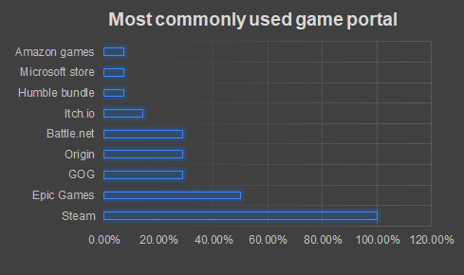Platform Preference:

Visual Theme Preference:

Number of Owned Games:

Based on the above survey findings the following assumptions have been made about the Clients Users:

* 57% of users are within the age range of 16-27.
* 43% of users browse for content on a weekly basis.
* Of the surveyed users 100% use Steam, 50% of which also use Epic Games, other platforms are occasionally used.
* 79% of users prefer to use a dark mode visual style, with Blue as a favourite colour for elements.
* 57% of users own either 31-70 games, 71-100 games, or 200+ games. With the exception of 7% of users, the rest of the users (about 36%) own more or less than the above figures.

In summary, most users are young adults, who browse for content weekly. They probably use Steam most often, prefer a darkmode which is easy on the eyes, and own a varied number of games, probably about 100.

This is our clients most likely target audience.

## Competitor Analysis

In order to analyse our competitors pain points and success points we will be taking a look at 2 examples from 2 competitors. These are Galaxy of Games, and Epic Games. We will look at their homepages, and 1 specific task for each, for this we have chosen a filtered search for First Person Shooter games, at $NZD 100.00 or less.

Following this analysis, we will take away from this with Inspiration going forward to help a redesign of our webpage for efficiency and enjoyment for the Clients’ users. We will have a clear understanding of pain points, , as well as success points to help determine the plausible fundamentals for the clients redesign.

Galaxy of Games:

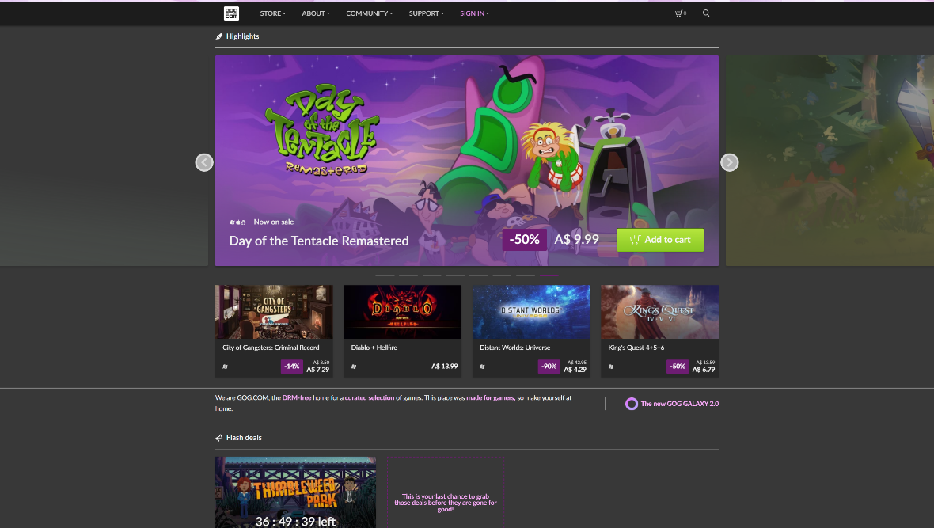Homepage

|  |  |
| --- | --- |
| Pros | Cons |
| Main menus are clearly visible at top | Features banner is too large and cannot be hidden |
| Each game clearly has a price, and a discount shown if applicable | There is very little content and no filters displayed to find games, due to the above con. |

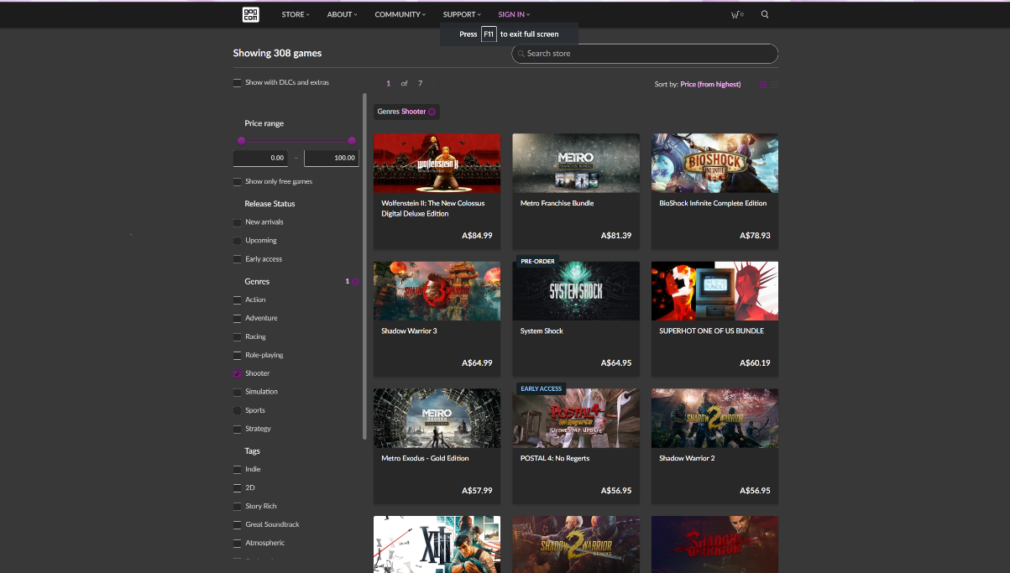First Person Shooter, $NZD 100.00 or less (search filters)

|  |  |
| --- | --- |
| Pros | Cons |
| Easily view content, and filters which are affecting what user sees | Can’t hover over a game for more information |
| No additional pop up or large content distracting from main content | Can’t hide and show the filters for more/less games viewable |

Epic Games:

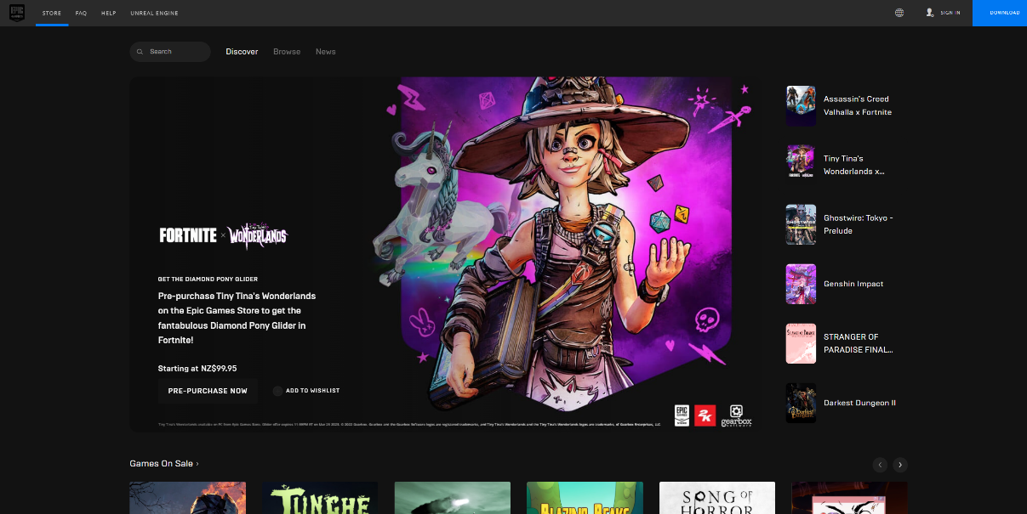Homepage

|  |  |
| --- | --- |
| Pros | Cons |
| Just like GoG, the main menus are easy to locate and use at the top | Also similar to GoG but even worse, is how large the featured content is, and no additional content is displayed properly, with no ability to hide the featured content. |
| Viewing the other featured content in mini next to the banner is a useful feature | The Search, discovery, browse features get lost a bit , perhaps enlarge or move |
| Getting the option to channel through the games on sale is a great space saving feature. | Language and sign in options at top right are too small, need to be larger to find easily. |

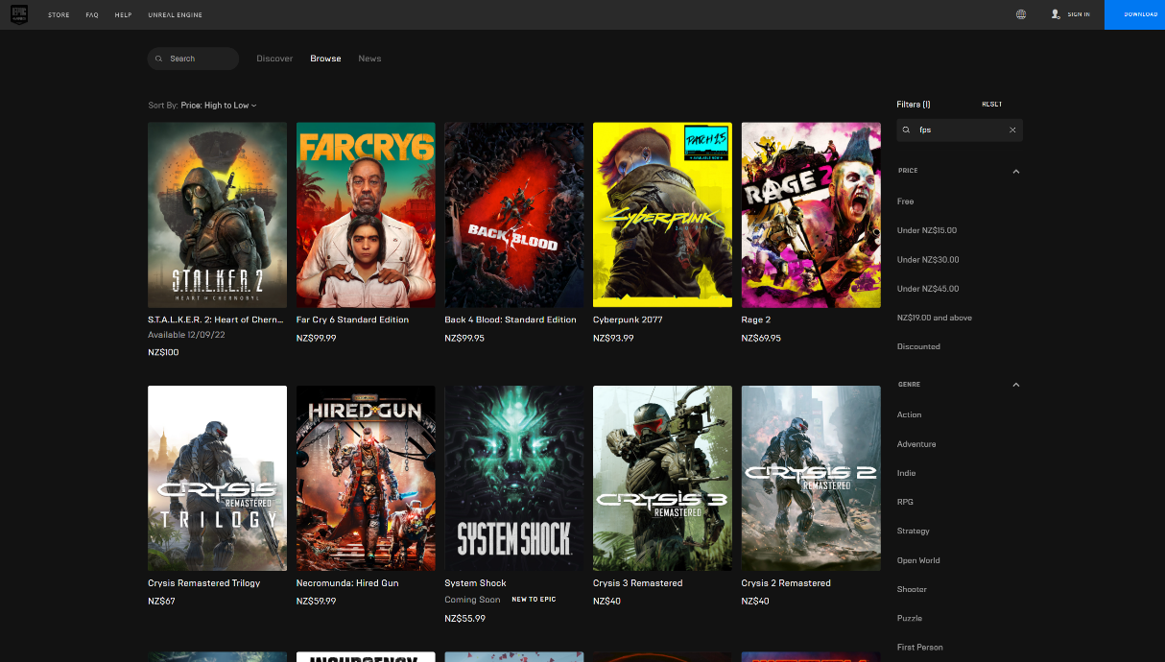First Person Shooter, $NZD 100.00 or less (search filters)

|  |  |
| --- | --- |
| Pros | Cons |
| Easily see ten choices right away | Price is difficult to see, as are discounts |
| Search and filters easy to see and use | Like GoG can not hover over game for more information |
| Can quickly reorganise with Sort By from above the games |  |

## Inspiration

In take away from the Competitor Analysis and the Clients own Website, some inherent inspiration we have found are as follows

* Featured content banners are often too large and take up valuable content space, also cannot be hidden
* Some menus are not easily visible or in the wrong location and get lost. This means potentially very useful features are overlooked or simply not used
* The most useful feature apparent from the competitors was the ability to apply and remove filters and sorting criteria to the displayed results, without navigating away from the page at all. You can constantly change your search criteria from A to Z and never once leave the page making direct comparison an enjoyable and speedy process.
* Placing main menus at top / centre helps to give bearing and navigation options to the user in a way that makes sense and does not confuse.
* A missing feature is more information on mouse over a game. This can be very handy to fill in gaps while keeping clutter off the page.
* A large and obvious button to link to the index is important, incase you find yourself lost on a separate page, and want to get back to the index.
* The ability to sign in or download the desktop client should be at top and bottom ribbon, easy access.

## Assumptions moving forward

Going forward, we can assume that the features banner needs to be generally smaller, and able to be hidden from sight on a timeframe easily chosen by the user based on their needs. Menus or features that are too small, or poorly placed can become lost. In contrast, menus which are enlarged and centred at the top or bottom are much more easily found. Allowing for filters and sortation functions to keep the user centred on one index page increases User Experience and helps the User with research and purchasing. It can feel detrimental to the experience without clear pricing / specials displayed, or no additional info displayed on mouse over.

Home button, sign in and download client should be clearly visible, preferably at the top.

# Research Phase

## Tasks for the User

To find pain points and successful aspects of the website, we chose five tasks for the users to complete to test and highlight possible fixes. Tasks listed below. *All tasks were timed, and mouse clicks were counted. This info can be found beneath the following observations.*

* Task 1: Find Cyberpunk 2077 store page
* Task 2: Find the discussion forums for Stardew Valley
* Task 3: Find the browsing page for RPG games under $20
* Task 4: Find out how to download the application
* Task 5: Find your games collection

## Observations made during User tasks

User 1 Task Observations:

1. Used the search function. Instant result
2. Initially tried searching for it, found reviews first, not correct, then found view discussions on the side.
3. Struggled a lot to find the filters for games – it is not that easy to find
4. Installed Steam app immediately no issue
5. Initially missed the listed owned games, then struggled to find it. Eventually found it a minute later or so.

User 2 Task Observations:

1. Did not have any trouble finding specified game
2. Did not have any trouble finding Discussion Forum
3. Became irritated about not being able to find the filters to apply
4. No trouble, instant result
5. Also no difficulties finding game collection.

User 3 Task Observations:

1. Used search function, took some time to find birth year on age dropdown.
2. Went through the community tab, then used the search feature in the discussions section, after which the link from a specific thread was clicked in order to get to the main forum.
3. Used left sidebar RPG category. was hoping for filters but could not find any, went back to home page to start fresh, tried looking at ‘new releases’ in order to find the category search page, quickly went back to home page again. Went back into the RPG section on the left sidebar, clicked the “Browse all new releases” button and landed on the browse page with the filters, from there quickly found the RPG filter and the price narrow option.
4. No trouble, instant download
5. Checked all the tabs for a while to find without clicking, selected “followed games & software” in store tab, and then got it straight away.

User 4 Task Observations:

1. No trouble
2. No trouble
3. Took a while to apply filters correctly, but completed in 1 minute
4. No trouble
5. No trouble

User 5 Task Observations:

1. No trouble, used search bar
2. Searched Stardew valley in search, tried to search “discussions” in tag search bar, searched around for a bit, checking tab drop-downs, went to community tab and clicked “discussions”, searched “Stardew valley” in the discussions search bar and found it.
3. Clicked “top sellers” in sidebar, changed price filter to < $20, and added RPG category filter.
4. Install button was greyed out so it took longer to find.
5. Clicked on username, and then clicked on games. Very fast

Amount of Clicks Vs. Time Taken

## Qualitative questions

In this section we asked users about their experience after using the website, the questions they were asked are as follows:

1. How easy was it to install the client?
2. How easy was it to find a game using category and price filters?
3. Did you find anything which was difficult, or easy, and why?
4. What do you think about the community hub?
5. Did you find anything to be frustrating, or enjoyable, and why?
6. Did you like or dislike anything, and why?  
     
   Responses from the Users

User 1

1. How easy was it to install the client?

It was relatively difficult in comparison to installing other applications.

1. How easy was it to find a game using the category and price filters?

I found this one quite taxing to figure out how to use. It wasn’t obvious.

1. Did you find anything which was difficult, or easy, and why?

From what I remember I really struggled with the last task you had me perform. I did find it quite easy to just type in the search bar to find a game though.

1. What do you think about the community hub?

I found it not that engaging, and I feel like I’d be more inclined to head towards a subreddit for a specific game community.

1. Did you find anything to be frustrating, or enjoyable, and why?

I feel like the webpages overall could be a bit cleaner and easier to find what you’re looking for as trying to figure out how to filter searches was difficult. I enjoy the branding of steam, feel like it could be incorporated more into the design of pages but still in a minimalistic way.

1. Did you like or dislike anything and why?

Overall, I wasn’t the hugest fan of navigating steam. I feel like the profile and community pages could have a stronger presence, especially in terms of troubleshooting problems within the games you’d be playing.

User 2

1. How easy was it to install the Steam client?

I found the client very easy to install, with the button being a different colour.

2. How easy was it to find a game using category and price filters?

Very hard, it was terribly unintuitive to find the filter section when looking at categories. I believe that if you click a category

it should then link to the browse page with the chosen category selected as one of the filters.

3. Did you find anything which was difficult, or easy, and why?

Searching was easy, installing the client was easy, but discovery for a specific genre or price range was hard to find.

4. What do you think about the community hub?

I personally never use the community hub, but I can see its value. Considering the value of the community page

I would have thought it would be easier to find the hub for a specific game.

5. Did you find anything to be frustrating, or enjoyable, and why?

The colours of the site were okay, but I think they could probably follow more structure, the install button is green for example

even though the rest of the site uses a dark/blue theme.

6. Did you like or dislike anything, and why?

There is too much clutter on the website, I get overloaded by too many options on the main screen.

User 3

1. How easy was it to install the game?

pretty easy, two clicks.

2. How easy was it to find a game using category and price filters?

I got lost in several pages and menus, for a good few minutes, I would prefer to remain on one page, and have filters to automatically update the content I see.

3. Did you find anything which was difficult, or easy, and why?

I found it difficult trying to locate specific sections of Steam when asked to, because they information architecture is just too different on each page, and there are too many pages.

4. What do you think about the community hub?

It lacks the ability to search by filter and perhaps is not organised as efficiently as possible.

5. Did you find anything to be frustrating, or enjoyable, and why?

Only thing that was frustrating was locating specifics using different pages and I.A. layouts

6. Did you like or dislike anything, and why?

I like how easy it was to install the client, I didn’t like the IA or the lack of filter functions.

User 4

1. How easy was it to install the game?

It was relatively easy since I have been using Steam for a while. Just a couple clicks

2. How easy was it to find a game using category and price filters?

I got lost a lot when trying to find the filters. When I had finally found it, I ended up trying to search for the specific tag and took me straight there. Maybe some clarity between the search and browse function would be good to be implemented

3. Did you find anything which was difficult, or easy, and why?

It was rather difficult trying to find the categories. Some clarification would be good to make it easier for newer users.

4. What do you think about the community hub?

It feels as if it's only there to be there and that there isn't really much care and time put into it compared to the rest of Steam.

5. Did you find anything to be frustrating, or enjoyable, and why?

The thing I found frustrating was the fact that finding a game that you don't know is difficult for the user as there isn't any clarity given immediately if you try and click on a specific category.

6. Did you like or dislike anything, and why?

It was relatively easy to install Steam and I like the colour scheme of Steam as it currently is. The usability needs to be tweaked a lot more to make it more beginner friendly

User 5  
1. How easy was it to install the client?

As we were already signed in the box was grey in colour making it harder to see. As it was difficult to see it made it hard to find.

2. How easy was it to find a game using category and price filters?

It was reasonably straightforward

3. Did you find anything which was difficult, or easy, and why?

As I was already signed into the web client it made it difficult to find the install button due to the colour.

4. What do you think about the community hub?

it was originally hard to find, but once found it was easy to navigate around.

5. Did you find anything to be frustrating, or enjoyable, and why?

Frustrating part, searching for the discussion forum, couldn’t find it easily

6. Did you like or dislike anything, and why?

I liked how easy it was to find the price filters when searching for a game

## Quantitative questions

In order to gain a better understanding of the users, we collected some statistical information in a closed question survey listed below. The answers to these questions can be found in the next section – Analysis Phase. This is listed after the survey questions below.

1. What is your Gender?
2. What is your Age?
3. What is your highest level of education?
4. What is your individual income in NZD?
5. How much money would you spend on games on Steam per month in NZD?
6. How often do you buy games only because they are on sale on Steam?
7. How frequently do you purchase games on Steam?
8. How often do you use the community page on Steam?
9. How many hours per week do you spend playing Video Games on Steam?

# Analysis Phase

## Research Summary

Gender

In this section we wanted to find out what our dominant user’s gender was. This was conclusively male.

Age

Here we wanted to look at the dominant age of users. Our answer was conclusively between the ages of 24 - 28

Literacy of Users

In this graph, we wished to gain a brief insight into the

Overall literacy of our users. Two of the highest percentages were University degree and NCEA Level 3.

It is therefore our belief that on the whole, the users are

Well informed.

Average Income of Users

This sections topic of interest was about the average income of users. The top two categories were:

Less than NZD $14,999 and NZD $50,000 - $69,999. Both

of which had 22% of users.

Average spend per user

Here we looked at the average spend per user, per month. By following the trendline we can see that over 50% of users spend less than NZD $20.00 a month, and 9% of users spend above NZD $101.00 per month.

Flash sale expenditure

In this graph, we specifically looked at the likelihood a user has of taking advantage of sale prices. The largest statistic shows about 30% of users are 80% likely to shop with a sale / discounted price.

Frequency of game purchase

Here we simply analyzed the frequency of purchases made by users. The largest statistic shows 48% of users shop roughly monthly.

Community page usage

In this graph we found the percentage of users which frequent the community page, and how often roughly.

Time spent in game weekly

To this effect, we simply wanted to find the average playtime of users. The greatest figure here is 11-25 hours per week with 38% of users.

## Personas

|  |  |  |  |  |
| --- | --- | --- | --- | --- |
| NAME  SOFIA GARCIA | OCCUPATION  RECEPTIONIST / ADMIN  (In a dentistry) | | | INCOME  $62,000 |
| smiling woman wearing white and black pinstriped collared top | HIGHEST LEVEL OF EDUCATION  Diploma  WEEKLY GAMEPLAY  15 hours average  LIKELIHOOD OF PURCHASING ON SALE  80% | FREQUENCY OF GAME PURCHASE  4 months average  AVERAGE SPEND PER MONTH  NZD $29.00  FREQUENCY OF COMMUNITY PAGE USE  2: Seldom | | |
| DEMOGRAPHIC  Female 30 Years  New Zealand  Defacto  Relationship 4 years  AMERICAN HISPANIC | BACKGROUND    Sofia has been a user of Steam for several years. She plays a lot of simulation and farm games. Sofia prefers to relax with games rather than get competitive.  Sofia browses Steam very rarely because she tends to save money rather than spend. She tends to look at buying games approximately twice a year.  She is very computer literate so doesn’t usually have problems navigating Steam, but finds the website cluttered and inefficient.  Sofia has been a teacher so has a lot of experience with children and believes this website is not very child friendly both in terms of complexity and content. | | | |
| PORTALS OF CHOICE  #1. Steam  #2. Origin | THEME / BROWSER PREFERENCE  White Heavy Check MarkWebsite Default  ~~Light Theme~~  ~~Dark Theme~~ | | FAVOURITE GAMES   * Stardew Valley * Minecraft * The Sims 4 | |

|  |  |  |  |  |
| --- | --- | --- | --- | --- |
| NAME  DWAYNE PōHAKU | OCCUPATION  IT ANALYST  (Part time) | | | INCOME  $26,000 |
| man wearing white V-neck shirt | HIGHEST LEVEL OF EDUCATION  Certificate  WEEKLY GAMEPLAY  26 hours average  LIKELIHOOD OF PURCHASING ON SALE  50% | FREQUENCY OF GAME PURCHASE  Once yearly average  AVERAGE SPEND PER MONTH  NZD $15.00  FREQUENCY OF COMMUNITY PAGE USE  4: Less than occasional | | |
| DEMOGRAPHIC  Male 36 Years  New Zealand  Dating 7 months  HAWAIIAN | BACKGROUND    Dwayne has used steam since he was in High School. He tends to play a lot of RPG and Action/Adventure games. Dwayne prefers playing a game with a story which has some level of challenge. Dwayne browses Steam monthly and looks to purchase games that are on sale, however if there is a game he really wants, he is happy to pay full price for it. He prefers to spend around $20-$50 per month on games.  He is very computer literate so doesn’t have any problems navigating Steam, he enjoys the layout and look of Steam however he can see that it has its’ downfalls.  Dwayne has younger siblings who also use Steam and often finds them asking questions about where to find information. Because of the difficult nature of finding information within the website/client Dwayne often shows his younger siblings third party websites as they find others more intuitive. | | | |
| PORTALS OF CHOICE  #1. Steam  #2. Epic Games | THEME / BROWSER PREFERENCE  ~~Website Default~~  ~~Light Theme~~  ~~White Heavy Check Mark~~Dark Theme | | FAVOURITE GAMES   * The Witcher III: The Wild Hunt * Elden Ring * Skyrim | |

|  |  |  |  |  |  |
| --- | --- | --- | --- | --- | --- |
| NAME  Erik Vries-Koning | | OCCUPATION  STUDENT  (Works part time at The Warehouse) | | | INCOME  $13,500 |
|  | HIGHEST LEVEL OF EDUCATION  NCEA LEVEL 3  WEEKLY GAMEPLAY  22 hours average  LIKELIHOOD OF PURCHASING ON SALE  95% | | FREQUENCY OF GAME PURCHASE  7 months average  AVERAGE SPEND PER MONTH  NZD $10.00  FREQUENCY OF COMMUNITY PAGE USE  3: Infrequent | | |
| DEMOGRAPHIC  Male 22 Years  New Zealand  Single  Dutch-American | BACKGROUND    Erik has used steam since he was in his final years of intermediate school. He tends to play a lot of PvP open-world games. He finds himself enjoying competitive games rather than playing games to relax, however he still doesn’t limit himself to just PvP games.  Erik browses steam on a weekly basis to see if there are any games on sale. He tends to spend his money on games rather than save, however he still primarily looks to buy games if they are on sale. Erik grew up as an only child, so had to teach himself how to use Steam effectively, however due to clutter he gets lost and frustrated easily. He likes the search function but hopes in future more filters and functions could be added. | | | | |
| PORTALS OF CHOICE  #1. Steam  #2. Battle.net  #3. Humble Bundle | THEME / BROWSER PREFERENCE  ~~Website Default~~  ~~Light Theme~~  ~~White Heavy Check Mark~~Dark Theme | | | FAVOURITE GAMES   * League of Legends * Conan Exiles * Rust | |

## Persona comparison to Strategy

As stated above my 3 personas are:

* Sofia Garcia, age 30 Female who is a working professional from New Zealand
* Dwayne Pōhaku, age 26 Male who is a part time IT Analyst from New Zealand
* Erik Vries-Koning, age 22 Male who is a student working part time living in New Zealand.

I have specifically built these personas using statistics from the research carried out, ensuring to have 3 quite different potential users of the website.

* Sofia falls in the main bracket or second main bracket for most of the researched material, so she is an average user.
* Dwayne was mostly comprised of the smallest stats making him an unusual user.
* Erik was comprised of a variety of stats which made sense with his description making him neither usual or unusual in habits.

|  |
| --- |
| Information from the Strategy Phase   * 57% of users are within the age range of 16-27. * 43% of users browse for content on a weekly basis. * Of the surveyed users 100% use Steam, 50% of which also use Epic Games, other platforms are occasionally used. * 79% of users prefer to use a dark mode visual style, with Blue as a favourite colour for elements. * 57% of users own either 31-70 games, 71-100 games, or 200+ games. With the exception of 7% of users, the rest of the users (about 36%) own more or less than the above figures.   In summary, most users are young adults, who browse for content weekly. They probably use Steam most often, prefer a darkmode which is easy on the eyes, and own a varied number of games, probably about 100.  This is our clients most likely target audience. |

|  |  |  |  |
| --- | --- | --- | --- |
| Direct Comparison of Personas to Information from the Strategy Assumptions | | | |
| Assumption Stat. | Sofia Garcia | Dwayne Pōhaku | Erik Vries-Koning |
| Age is 16-27 | 30 | 36 | 22 |
| Browse for games weekly | N/A in Research | N/A in Research | N/A in Research |
| Main client is Steam, followed by Epic or Others | Steam, Origin | Steam, Epic Games | Steam, Battle.Net, Humble Bundle |
| Dark Mode Vis. Theme Preferred | Website Default | Dark Theme | Dark Theme |
| The main brackets of owned games are (31-70), (71-100) or 200+ | N/A in Research | N/A in Research | N/A in Research |

Our spread of Personas is interesting, it does not match the Strategy Assumptions perfectly, nor does it 100% match the findings from the research phase. Rather, it is a nice mix of the two, the majority of which comes from the Research phase, and our average findings statistics.

Features and Fixes

|  |  |
| --- | --- |
| Feature / Fix | Pain Point / Basis |
| 1. Organise the bulk of the website into the index page using filters and refreshable content, rather than separate pages | When searching for content, most users took much more time to locate the filters function, or used a lot more clicks to find them, or both. Getting lost was too easy. |
| 1. Have a common menu to find sections that are necessary to keep in separate pages, and keep this menu on all pages to avoid getting lost. | Users could not easily find (for example, the discussion forum, or the about page, and flick back and forth without trouble) |
| 1. Group users own content, stats and profile | Users were struggling to find these details separately. |
| 1. Keep install client button one colour even when logged in | User could not find the button as was already logged in, unbeknown, and it was greyed out. |
| 1. Apply a show hide feature for the “featured” banner to allow users to carry on with browsing once they have seen the banner enough in their week or day. Allowing more content to be shown to browse. | This was not a pain point found by our users in research testing however it is my belief that it would enhance the User Experience giving the option to the user. |
| 1. Discussion Forum / Wishlist clarity | This would be nice to have accessible from a side menu, as mentioned above, for ease of access and convenience. More likely to be found, and used. |
| 1. Unify the User Experience and the Information Architecture specifically from desktop client to web client app. | One user found themselves getting lost in the web client as he was used to the desktop client, and the information architecture was different. |

Card Sorting

# Design Phase

## Style Guide

## Sketches

Initial Sketch (Desktop: 16:9) – Done during Research Phase as a Guide and a Test

Final Sketch (Desktop: 16:9) to take to Wireframe Step – completed after Analysis of Research

## Lo-fi Wireframe

## Lo-fi Testing

## Hi-fi Wireframe

## Hi-fi Testing

Bibliography